Table 1.–Annual adult pink salmon harvest data from Southeast Alaska (millions of fish). Temperature (°C) data from the Southeast Coastal Monitoring project at 20 m integrated depth averaged over the months of May, June, and July (MJJ; ISTI) from the years 1997 to 2021, satellite sea surface temperature data (°C) from the Chatham Strait region, Icy Strait region, northern Southeast Alaska (NSEAK) region, and Southeast Alaska (SEAK) region from the year 1997 to 2021 for the month of May (May), May through July (MJJ), April through June (AMJ), and April through July (AMJJ). The variable CPUE (Ln (CPUE+1); is the index of juvenile abundance of pink salmon abundance.

|  |  |  |  |  |  |  |  |  |  |  |  |  |  |  |  |  |  |  |  |
| --- | --- | --- | --- | --- | --- | --- | --- | --- | --- | --- | --- | --- | --- | --- | --- | --- | --- | --- | --- |
|  | Harvest | ISTI | Chatham Strait | | | | Icy Strait | | | | NSEAK | | | | SEAK | | | |  |
| Year | 42.50 | MJJ | MJJ | May | AMJJ | AMJ | MJJ | May | AMJJ | AMJ | MJJ | May | AMJJ | AMJ | MJJ | May | AMJJ | AMJ | CPUE |
| 1997 | 77.80 | 9.28 | 10.08 | 7.48 | 8.83 | 7.59 | 10.30 | 7.01 | 8.83 | 7.30 | 10.02 | 7.35 | 8.71 | 7.40 | 10.47 | 8 | 9.2 | 7.99 | 2.48 |
| 1998 | 20.30 | 9.40 | 9.85 | 7.83 | 8.91 | 7.88 | 9.97 | 7.34 | 8.85 | 7.56 | 9.89 | 7.65 | 8.85 | 7.71 | 10.36 | 8.37 | 9.38 | 8.37 | 5.62 |
| 1999 | 67.00 | 8.56 | 8.90 | 6.84 | 8.05 | 7.12 | 9.08 | 6.17 | 8.02 | 6.78 | 8.93 | 6.70 | 7.98 | 6.95 | 9.3 | 7.23 | 8.4 | 7.43 | 1.6 |
| 2000 | 45.30 | 8.77 | 9.70 | 7.34 | 8.62 | 7.52 | 9.94 | 7.02 | 8.67 | 7.35 | 9.70 | 7.23 | 8.57 | 7.39 | 10.02 | 7.71 | 8.95 | 7.86 | 3.73 |
| 2001 | 52.50 | 9.03 | 9.15 | 6.74 | 8.18 | 7.12 | 9.57 | 6.48 | 8.40 | 7.08 | 9.22 | 6.66 | 8.17 | 7.01 | 9.51 | 7.1 | 8.52 | 7.45 | 2.87 |
| 2002 | 45.30 | 8.20 | 8.97 | 6.39 | 7.85 | 6.64 | 9.34 | 6.26 | 8.02 | 6.60 | 9.05 | 6.39 | 7.88 | 6.61 | 9.44 | 6.92 | 8.33 | 7.14 | 2.78 |
| 2003 | 59.10 | 9.31 | 9.92 | 7.71 | 8.90 | 7.85 | 10.08 | 7.29 | 8.88 | 7.53 | 9.86 | 7.57 | 8.76 | 7.60 | 10.32 | 8.17 | 9.25 | 8.16 | 3.08 |
| 2004 | 11.60 | 9.33 | 10.43 | 7.94 | 9.22 | 7.96 | 10.68 | 7.53 | 9.25 | 7.69 | 10.38 | 7.89 | 9.09 | 7.79 | 10.98 | 8.58 | 9.74 | 8.51 | 3.9 |
| 2005 | 44.80 | 10.21 | 10.67 | 8.51 | 9.48 | 8.44 | 11.16 | 8.40 | 9.64 | 8.26 | 10.63 | 8.42 | 9.35 | 8.26 | 11.06 | 8.92 | 9.83 | 8.82 | 2.04 |
| 2006 | 15.90 | 8.75 | 9.78 | 7.16 | 8.68 | 7.58 | 10.19 | 6.84 | 8.86 | 7.49 | 9.72 | 6.98 | 8.55 | 7.36 | 10.19 | 7.63 | 9.07 | 7.96 | 2.58 |
| 2007 | 38.00 | 8.94 | 9.52 | 7.04 | 8.41 | 7.27 | 9.49 | 6.55 | 8.16 | 6.87 | 9.44 | 6.90 | 8.24 | 7.03 | 9.99 | 7.51 | 8.82 | 7.64 | 1.17 |
| 2008 | 24.00 | 7.91 | 8.65 | 6.77 | 7.69 | 6.83 | 8.85 | 6.43 | 7.72 | 6.68 | 8.65 | 6.64 | 7.63 | 6.74 | 9.18 | 7.22 | 8.17 | 7.28 | 2.32 |
| 2009 | 58.90 | 9.36 | 9.75 | 7.30 | 8.46 | 7.35 | 9.94 | 7.19 | 8.47 | 7.22 | 9.77 | 7.32 | 8.40 | 7.24 | 10.2 | 7.76 | 8.85 | 7.73 | 2.33 |
| 2010 | 21.30 | 9.35 | 9.65 | 7.97 | 8.66 | 7.93 | 9.87 | 7.71 | 8.68 | 7.81 | 9.62 | 7.76 | 8.54 | 7.72 | 10.09 | 8.28 | 9.05 | 8.23 | 4.11 |
| 2011 | 94.70 | 8.65 | 9.59 | 7.31 | 8.49 | 7.55 | 9.84 | 6.81 | 8.47 | 7.18 | 9.67 | 7.25 | 8.44 | 7.44 | 10.05 | 7.74 | 8.88 | 7.92 | 1.51 |
| 2012 | 37.20 | 8.48 | 9.17 | 7.07 | 8.18 | 7.22 | 9.23 | 6.92 | 8.10 | 7.07 | 9.14 | 6.95 | 8.09 | 7.10 | 9.68 | 7.47 | 8.63 | 7.61 | 3.52 |
| 2013 | 35.10 | 8.83 | 9.66 | 6.74 | 8.44 | 7.21 | 9.88 | 6.37 | 8.45 | 6.97 | 9.67 | 6.59 | 8.36 | 7.04 | 10.39 | 7.51 | 9.1 | 7.85 | 2.14 |
| 2014 | 18.40 | 9.12 | 9.98 | 8.17 | 8.76 | 7.77 | 10.23 | 7.90 | 8.81 | 7.62 | 10.03 | 8.15 | 8.70 | 7.64 | 10.57 | 8.62 | 9.26 | 8.17 | 3.8 |
| 2015 | 34.70 | 9.61 | 10.62 | 8.87 | 9.55 | 8.73 | 10.73 | 8.34 | 9.43 | 8.29 | 10.81 | 8.92 | 9.56 | 8.65 | 11.43 | 9.64 | 10.21 | 9.32 | 2.45 |
| 2016 | 8.10 | 10.20 | 11.04 | 8.92 | 10.03 | 9.07 | 11.65 | 8.81 | 10.37 | 9.14 | 11.18 | 8.92 | 10.05 | 9.00 | 11.67 | 9.61 | 10.59 | 9.59 | 4.35 |
| 2017 | 21.10 | 8.56 | 9.65 | 7.65 | 8.70 | 7.76 | 9.82 | 7.22 | 8.66 | 7.51 | 9.82 | 7.75 | 8.77 | 7.78 | 10.31 | 8.25 | 9.28 | 8.29 | 0.35 |
| 2018 | 8.07 | 8.92 | 9.87 | 7.40 | 8.75 | 7.61 | 9.99 | 6.92 | 8.74 | 7.43 | 10.11 | 7.53 | 8.86 | 7.63 | 10.79 | 8.28 | 9.54 | 8.3 | 1.17 |
| 2019 | 47.75 | 9.91 | 10.47 | 8.24 | 9.46 | 8.35 | 10.74 | 7.79 | 9.51 | 8.10 | 10.87 | 8.42 | 9.65 | 8.44 | 11.46 | 9.01 | 10.25 | 9.05 | 1.14 |
| 2020 | NA | 8.89 | 9.99 | 8.09 | 8.84 | 7.86 | 10.40 | 7.83 | 9.05 | 7.86 | 10.23 | 8.26 | 8.98 | 7.94 | 10.7 | 8.9 | 9.52 | 8.53 | 2.15 |
| 2021 | 42.50 | 8.89 | 10.06 | 7.25 | 8.90 | 7.63 | 10.26 | 6.91 | 8.91 | 7.47 | 10.23 | 7.29 | 8.96 | 7.65 | 10.82 | 7.97 | 9.58 | 8.31 | 0.88 |

Table 2.–Summary of model outputs including adjusted *R*-squared, inverse variance weighting (scaled to sum to one), and the 2022 forecast of adult pink salmon harvest from Southeast Alaska (millions; corrected for log transformation bias in a linear-model).

|  |  |  |  |  |
| --- | --- | --- | --- | --- |
| Model | Terms | Adjusted R2 | 2022 forecast (bias corrected; millions) | Inverse variance weighting (scaled to sum to one) |
| m1 | CPUE | 0.59 | 16.51 | 0.03 |
| m2 | CPUE , ISTI | 0.81 | 15.58 | 0.07 |
| m3 | CPUE, Chatham SST (May) | 0.79 | 16.40 | 0.05 |
| m4 | CPUE, Chatham SST (MJJ) | 0.74 | 13.31 | 0.06 |
| m5 | CPUE, Chatham SST (AMJ) | 0.79 | 14.84 | 0.07 |
| m6 | CPUE, Chatham SST (AMJJ) | 0.77 | 13.34 | 0.07 |
| m7 | CPUE, Icy Strait SST (May) | 0.77 | 15.88 | 0.05 |
| m8 | CPUE, Icy Strait SST (MJJ) | 0.73 | 13.73 | 0.05 |
| m9 | CPUE, Icy Strait SST (AMJ) | 0.76 | 14.35 | 0.05 |
| m10 | CPUE, Icy Strait SST (AMJJ) | 0.75 | 13.60 | 0.06 |
| m11 | CPUE, NSEAK SST (May) | 0.78 | 16.24 | 0.05 |
| m12 | CPUE, NSEAK SST (MJJ) | 0.75 | 13.14 | 0.05 |
| m13 | CPUE, NSEAK SST (AMJ) | 0.78 | 14.33 | 0.06 |
| m14 | CPUE, NSEAK SST (AMJJ) | 0.77 | 13.16 | 0.06 |
| m15 | CPUE, SEAK SST (May) | 0.76 | 15.70 | 0.04 |
| m16 | CPUE, SEAK SST (MJJ) | 0.73 | 13.06 | 0.05 |
| m17 | CPUE, SEAK SST (AMJ) | 0.77 | 13.88 | 0.06 |
| m18 | CPUE, SEAK SST (AMJJ) | 0.75 | 13.00 | 0.06 |

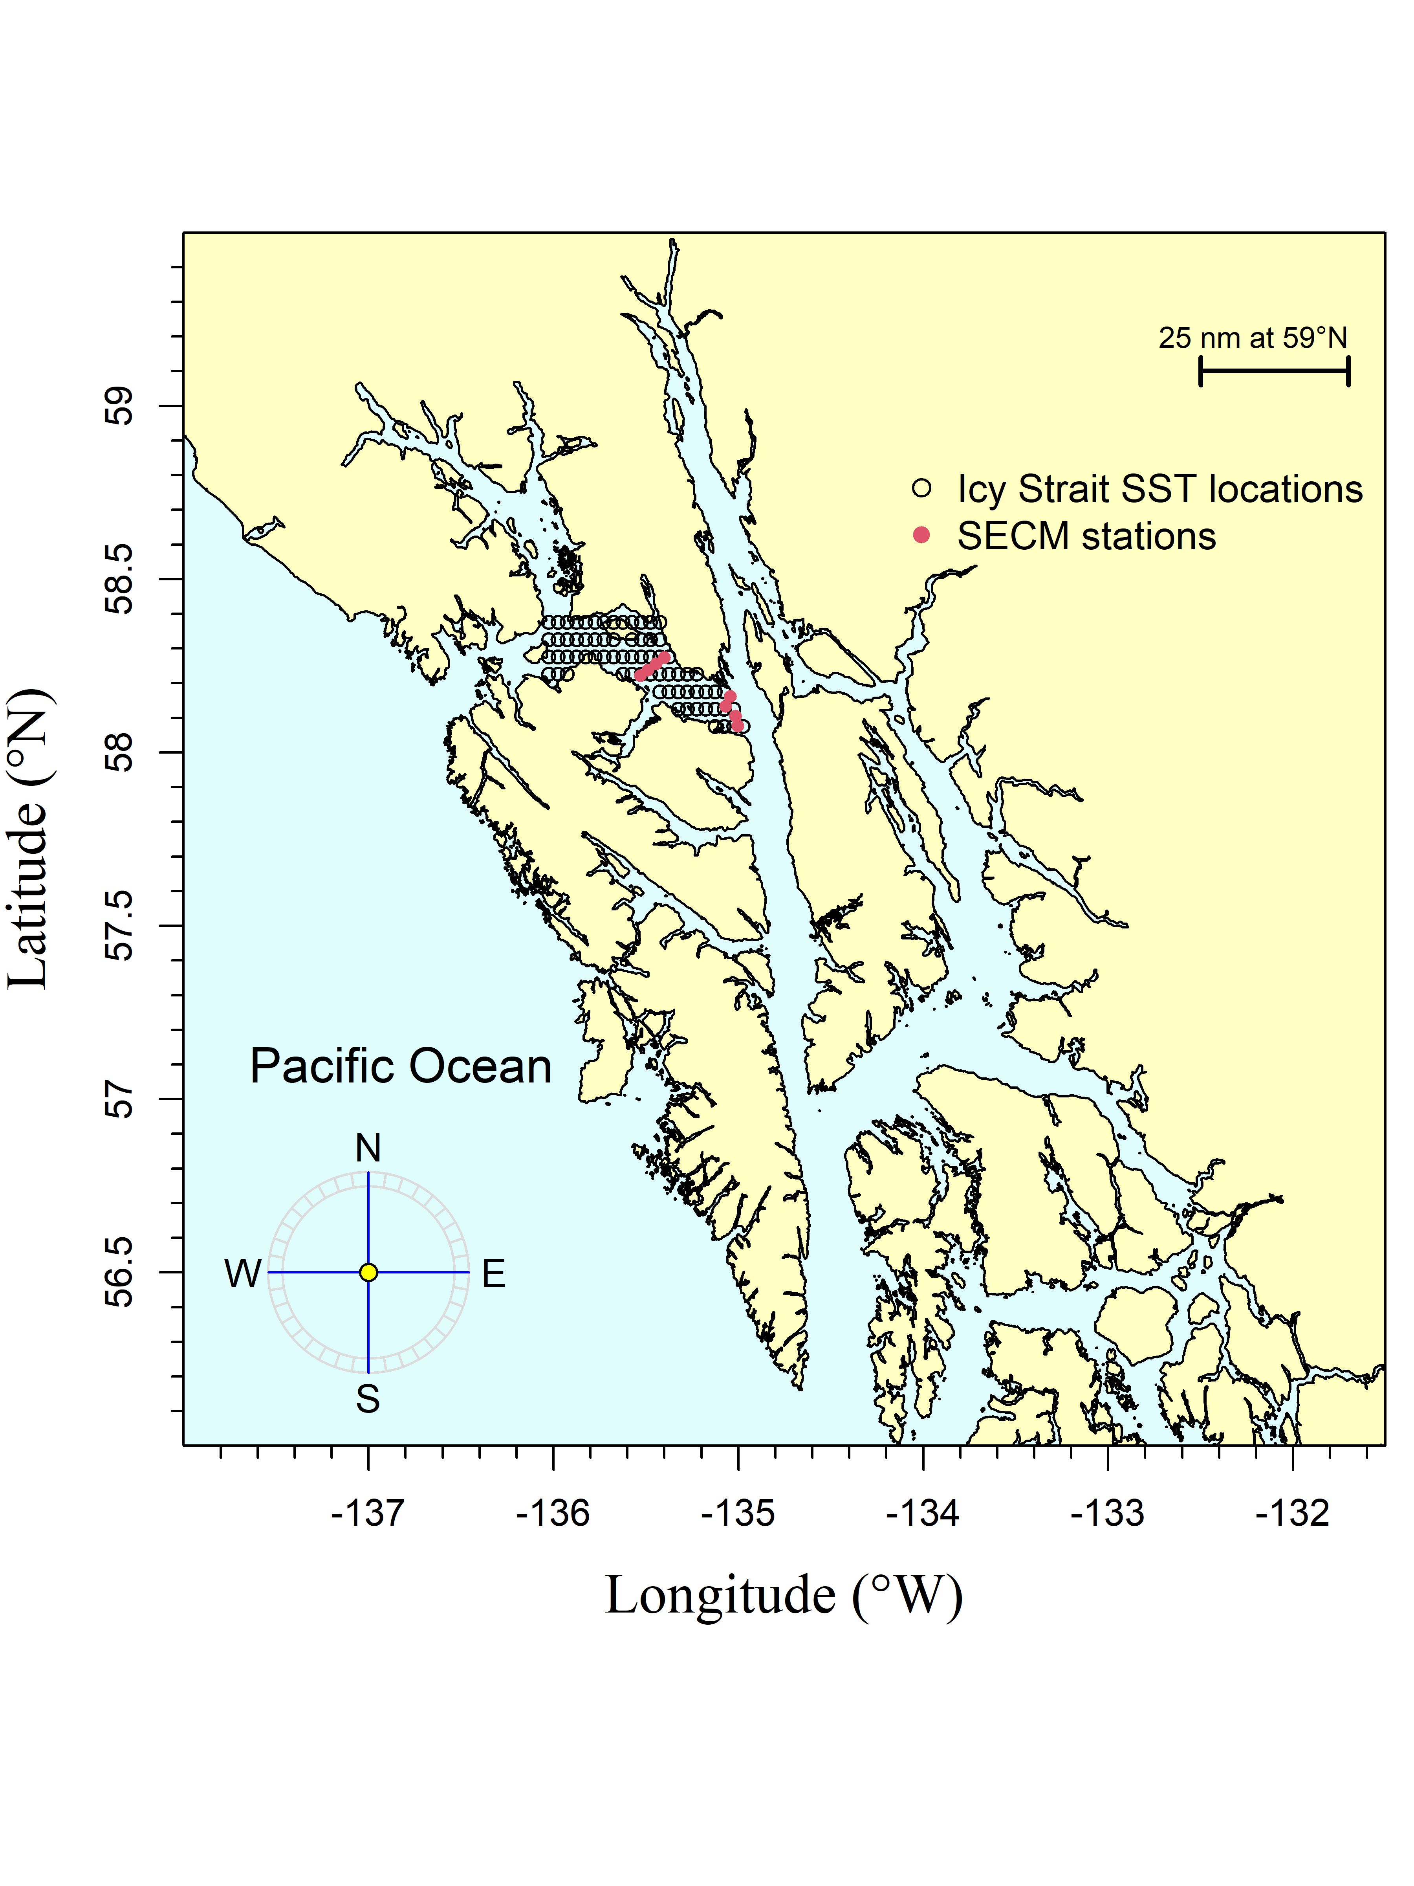

Figure 1.–The Icy Strait region encompasses waters of Icy Strait from the east end of Lemesurier Island to a line from Point Couverden south to Point Augusta. The Southeast Coastal Monitoring (SECM) project transects (Upper Chatham Strait and Icy Strait) are shown as red points for comparison to the satellite stations (i.e., data points; black circles). There were 70 satellite stations (latitude/longitude combinations) in the Icy Strait region.

Figure 2.–A. The May temperature averaged over each region (Chatham and Icy Straits, Icy Strait, NSEAK, SEAK) from 1997 through 2021. B. The May, June, and July temperature averaged over each region (Chatham and Icy Straits, Icy Strait, NSEAK, SEAK) from 1997 through 2021. C. The April through June temperature averaged over each region (Chatham and Icy Straits, Icy Strait, NSEAK, SEAK) from 1997 through 2021. D. The April through July temperature averaged over each region (Chatham and Icy Straits, Icy Strait, NSEAK, SEAK) from 1997 through 2021.

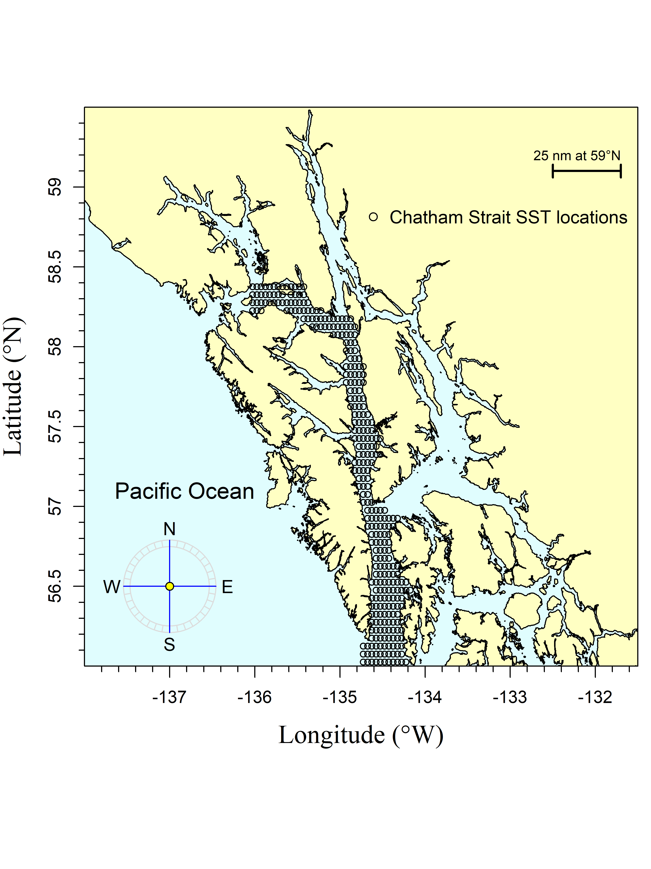

Figure 2.–The Chatham region encompasses waters of Chatham and Icy Straits east of Lemesurier Island to Point Couverden, south to the approximate latitude of 56.025 degrees north (roughly Cape Decision off Kuiu Island). The black circles are the satellite stations (i.e., data points). There are 313 satellite stations (latitude/longitude combinations) in the Chatham region.

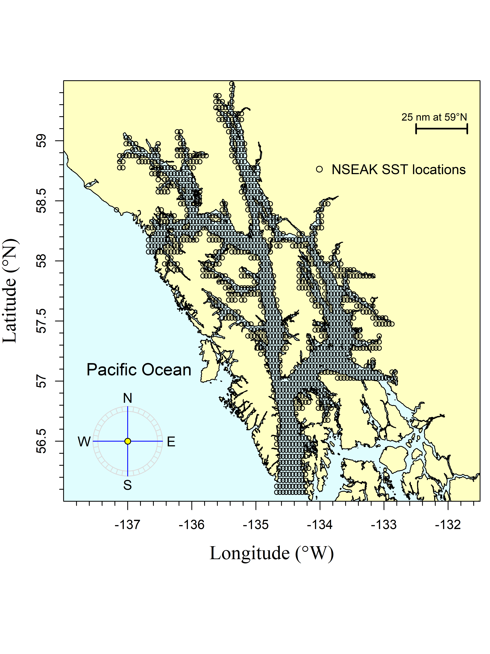

Figure 3.–The northern Southeast Alaska (NSEAK) region encompasses northern Southeast Alaska from 59.475 to 56.075 degrees north latitude and from -137.175 to -132.825 degrees west longitude. The black circles are the satellite stations (i.e., data points). There are 1,344 satellite stations (latitude/longitude combinations) in the NSEAK region.

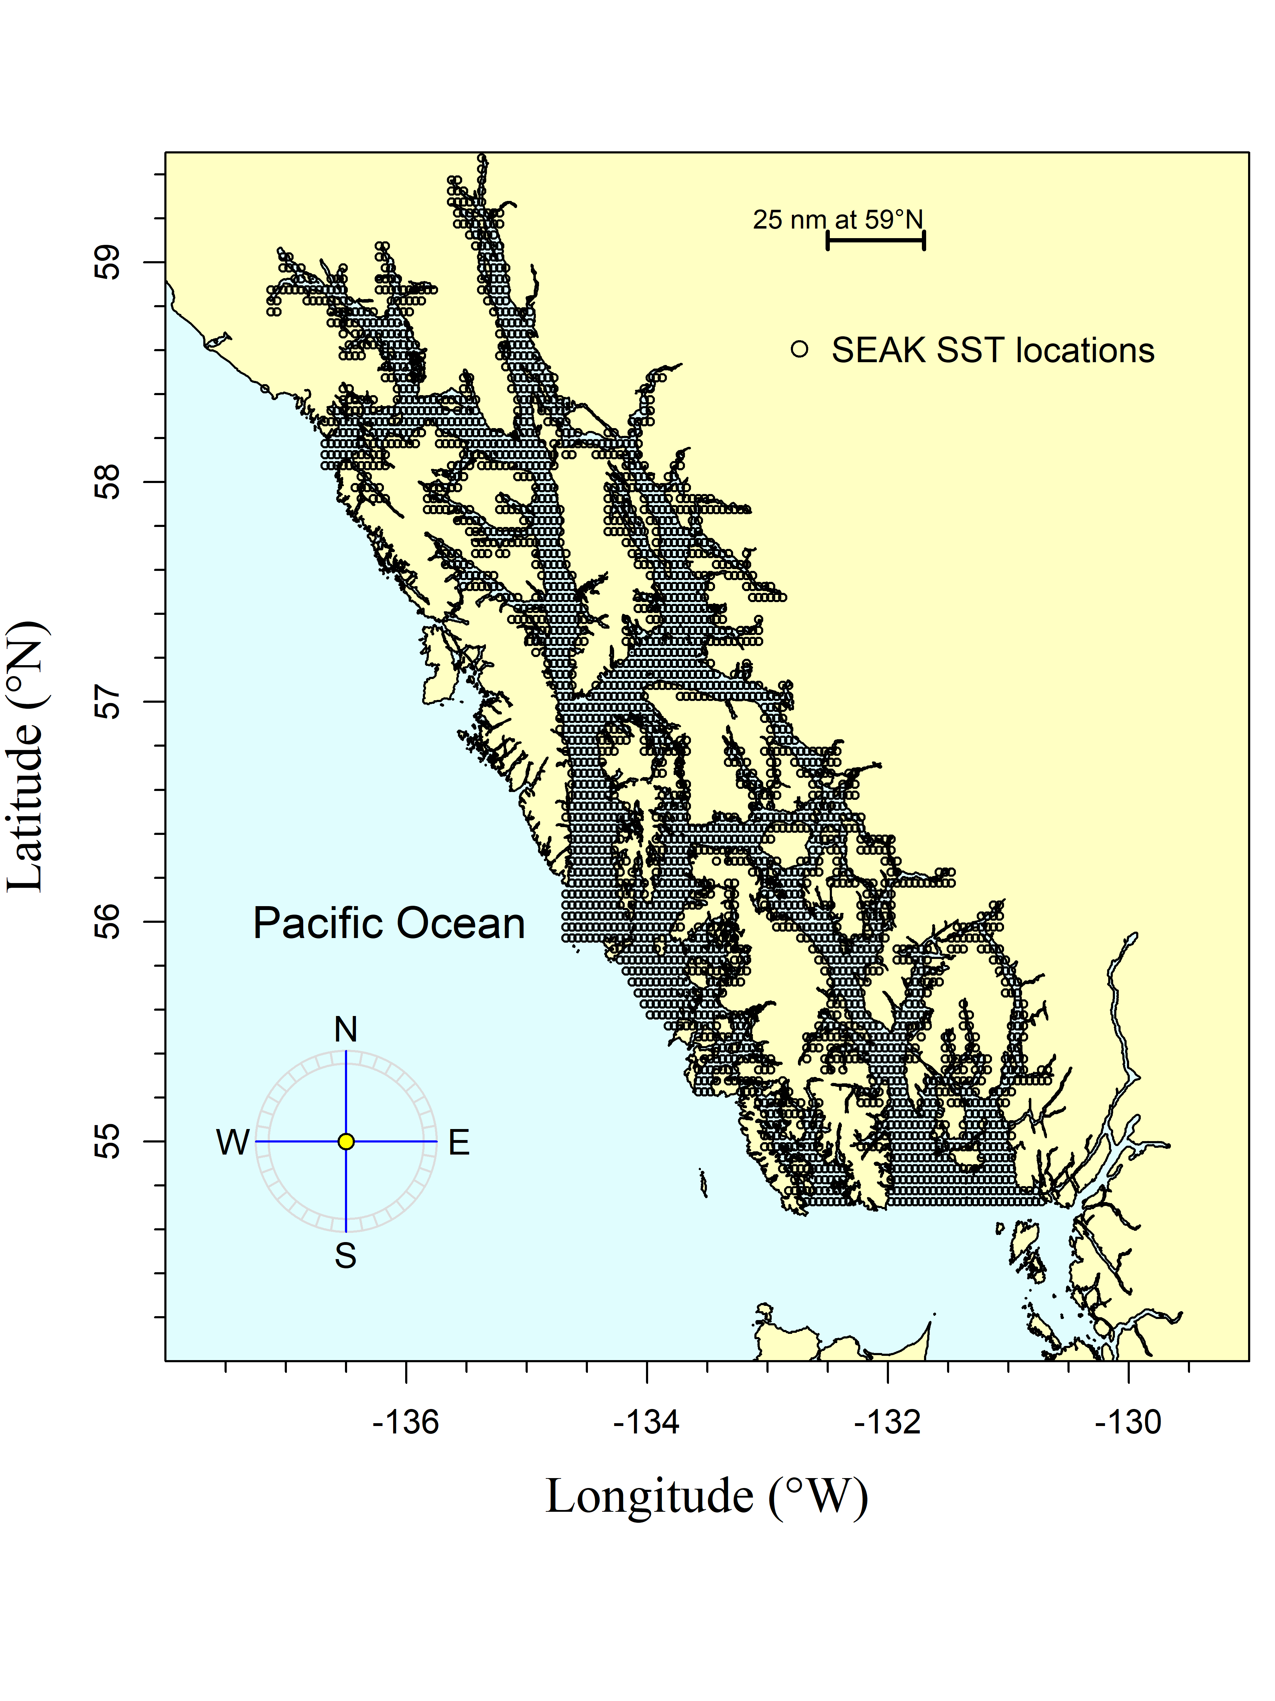

Figure 4.–The Southeast Alaska (SEAK) region encompasses Southeast Alaska from 59.475 to 54.725 degrees north latitude and from -137.175 to -130.675 degrees west longitude. The black circles are the satellite stations (i.e., data points). There are 2,669 satellite stations (latitude/longitude combinations) in the SEAK region

Figure 6.–Average temperature (degrees Celsius) at 20 m during May, June, and July at 8 stations in Icy Strait (Icy Strait and Upper Chatham transects; ISTI20_MJJ) from 1997 through 2021.

Appendix A Forecast time series methodology